 **Methods 11 Test 2 2018**

**Quadratic and Exponential Functions**

**Total Marks: 60 Time Allowed: 60 minutes**

**Name: _______________________**

**SECTION A – Resource Free**

**40 minutes – 43 marks**

**ALL** working must be shown for full marks.

**1.** **[3, 1, 1 = 5 marks]**

A parabola has the equation y = (x + 6)(10 – x).

a) Find the coordinates of the x and y intercepts of the parabola.

b) Find the equation of the line of symmetry

c) Find the coordinates of the turning point of the parabola and state the nature of the turning point.

**2. [8 marks]**

Complete the following table with the appropriate information.

|  |  |  |  |  |
| --- | --- | --- | --- | --- |
|  | **x–intercept** | **y-intercepts** | **Domain** | **Range** |
|  |  |  |  |  |
|  |  |  |  |  |

**3. [3, 3, 3, 7 = 16 marks]**

Solve the following exponential equations:

a) 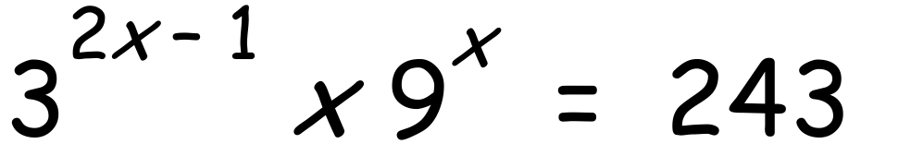 b) 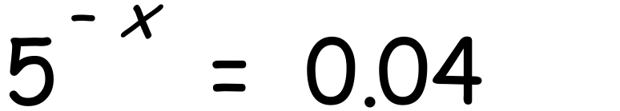

c) 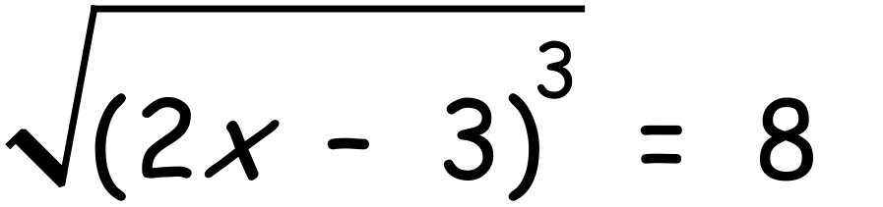 d) $4×2^{2x}-34×2^{x}+16=0 let p=2^{x}$

**4. [2, 2 = 4 marks]**

a) Find the value(s) for k for which x² - 10x + k = 0 has exactly one solution.

c) Find the value(s) for k for which kx² + 6x – 2 = 0 has no real solutions.

**5.** **[3, 3 = 6 marks]**

A parabola has the equation $y=f\left(x\right)where f\left(x\right)=k{\left(x+a\right)}^{2}+16$ where a is a constant.

a) Find a and k if the parabola has a turning point at (-2, 16) and $f\left(0\right)= -4$

c) Find a and k if $f\left(3\right)=f\left(-5\right)=0$

**6. [1, 1, 1, 1 = 4 marks]**

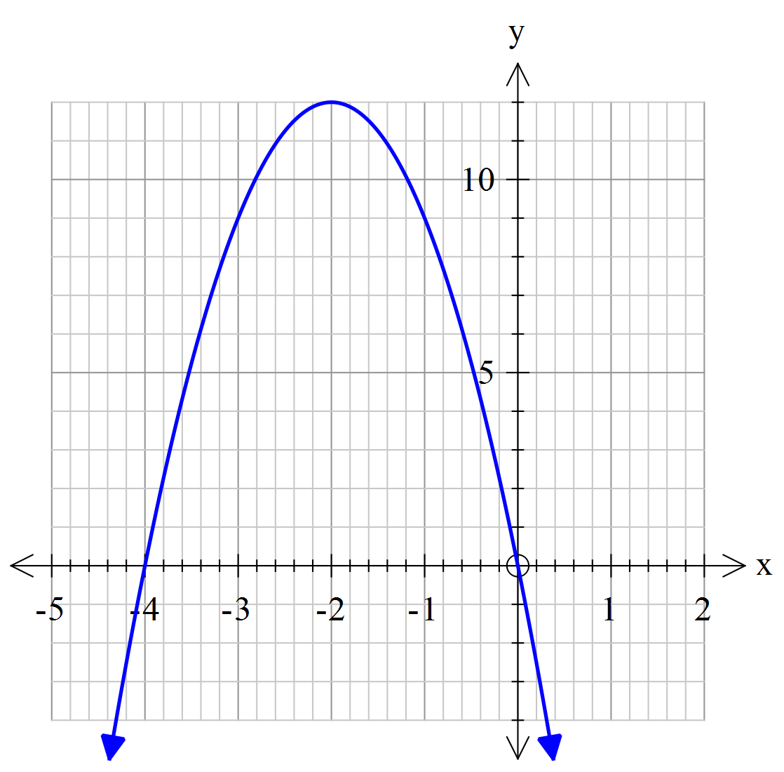

Consider the graph of y = f(x) shown.

Find the image of the point (-3, 9) under

the following transformations:

a) y = f(x+3)

b) y = f(-x)

c) y = f(2x) + 1

d) y = -2f(x)

**Methods 11 Test 2 2018 (functions)**

**Total Marks: 60 Time Allowed: 60 minutes**

**Name: _______________________**

**SECTION B – Calculators**  **20 minutes – 17 marks**

**7.** **[6 marks]**

Match the graphs with the equations.

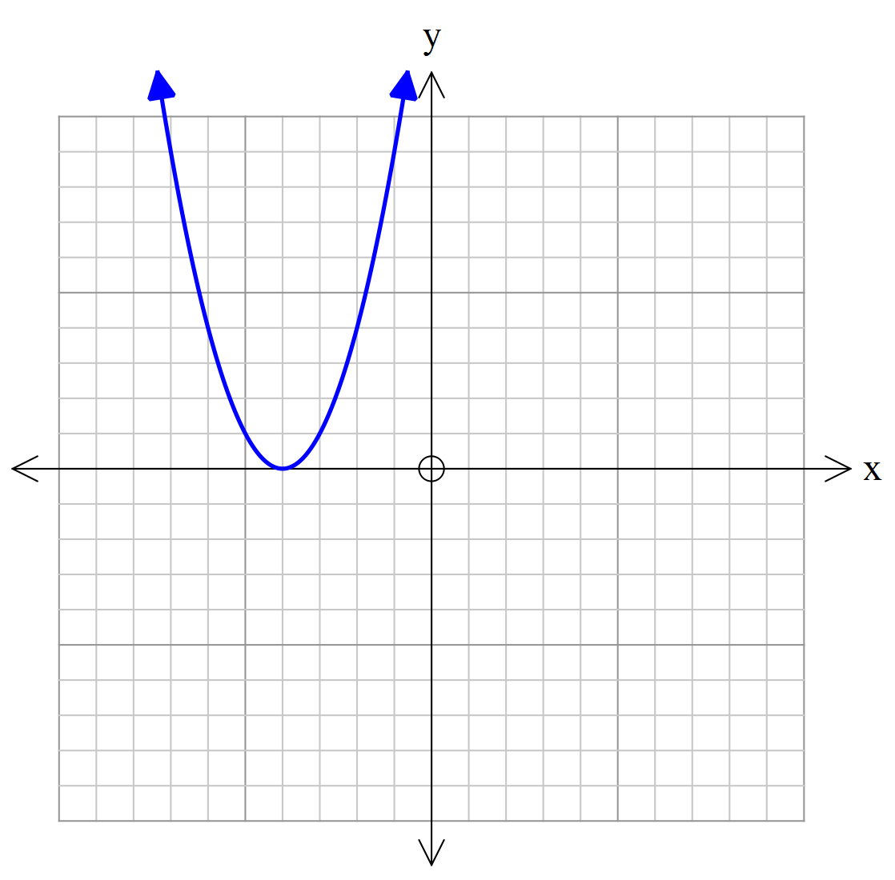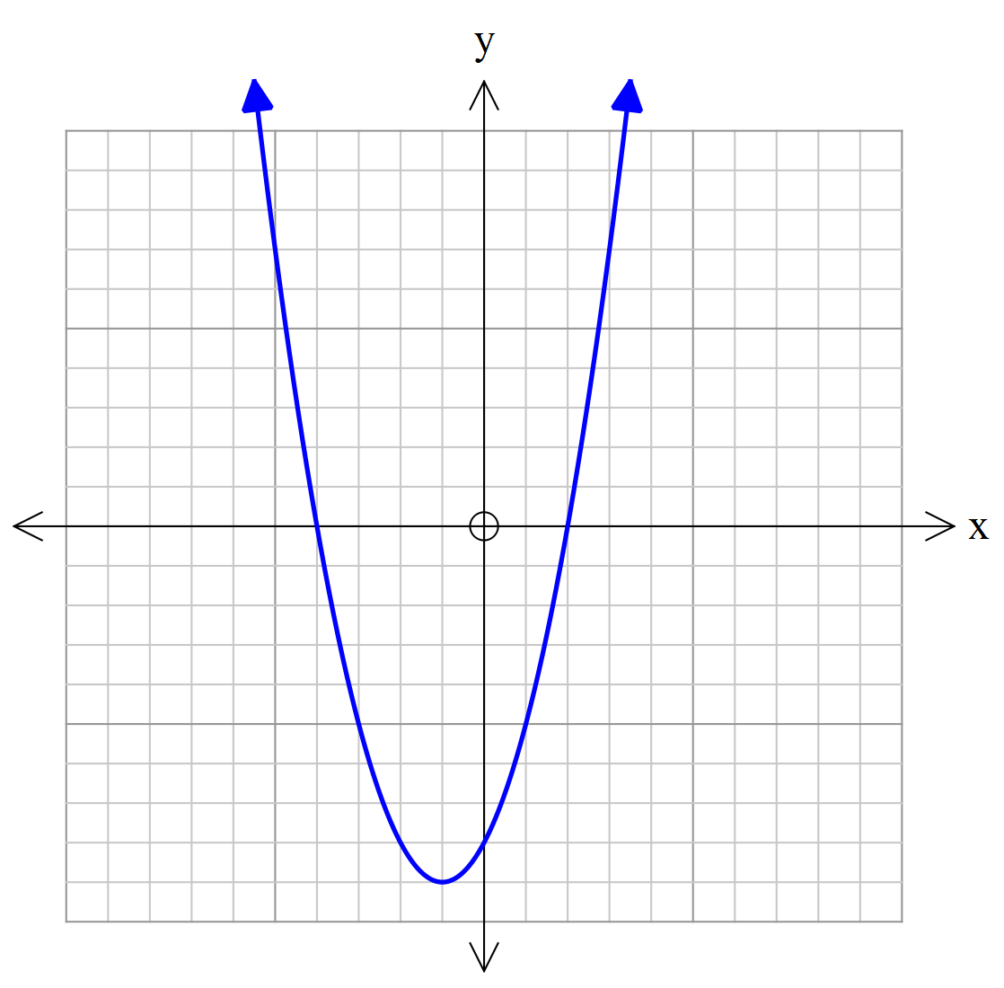

A

B

C

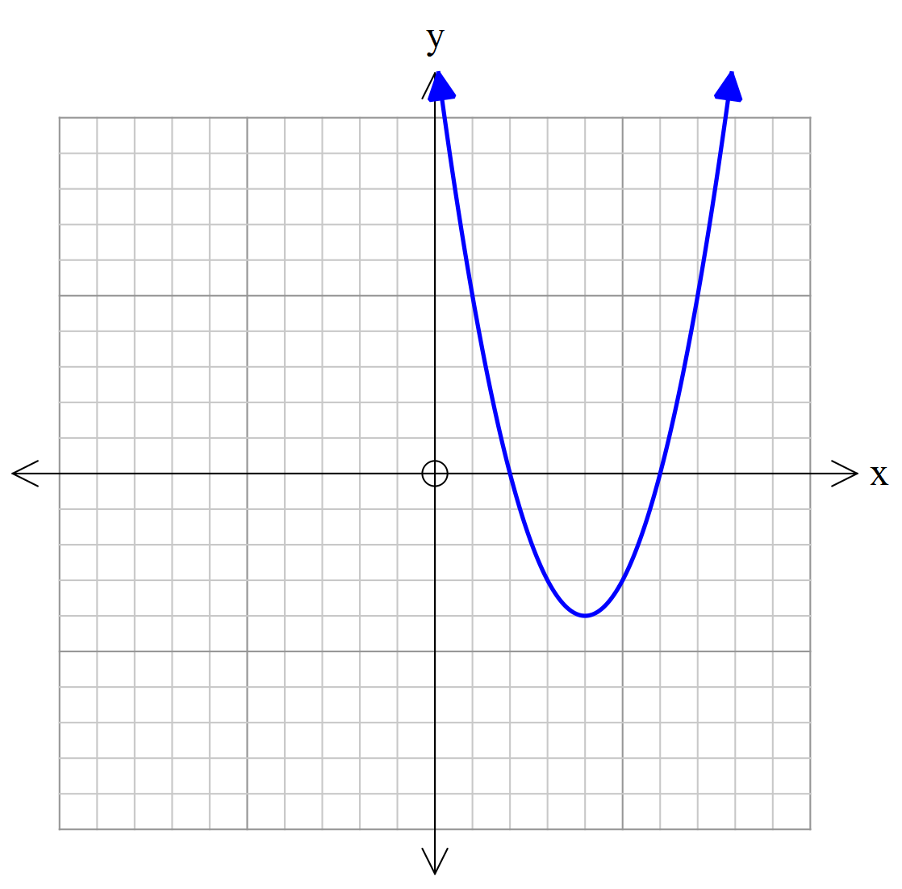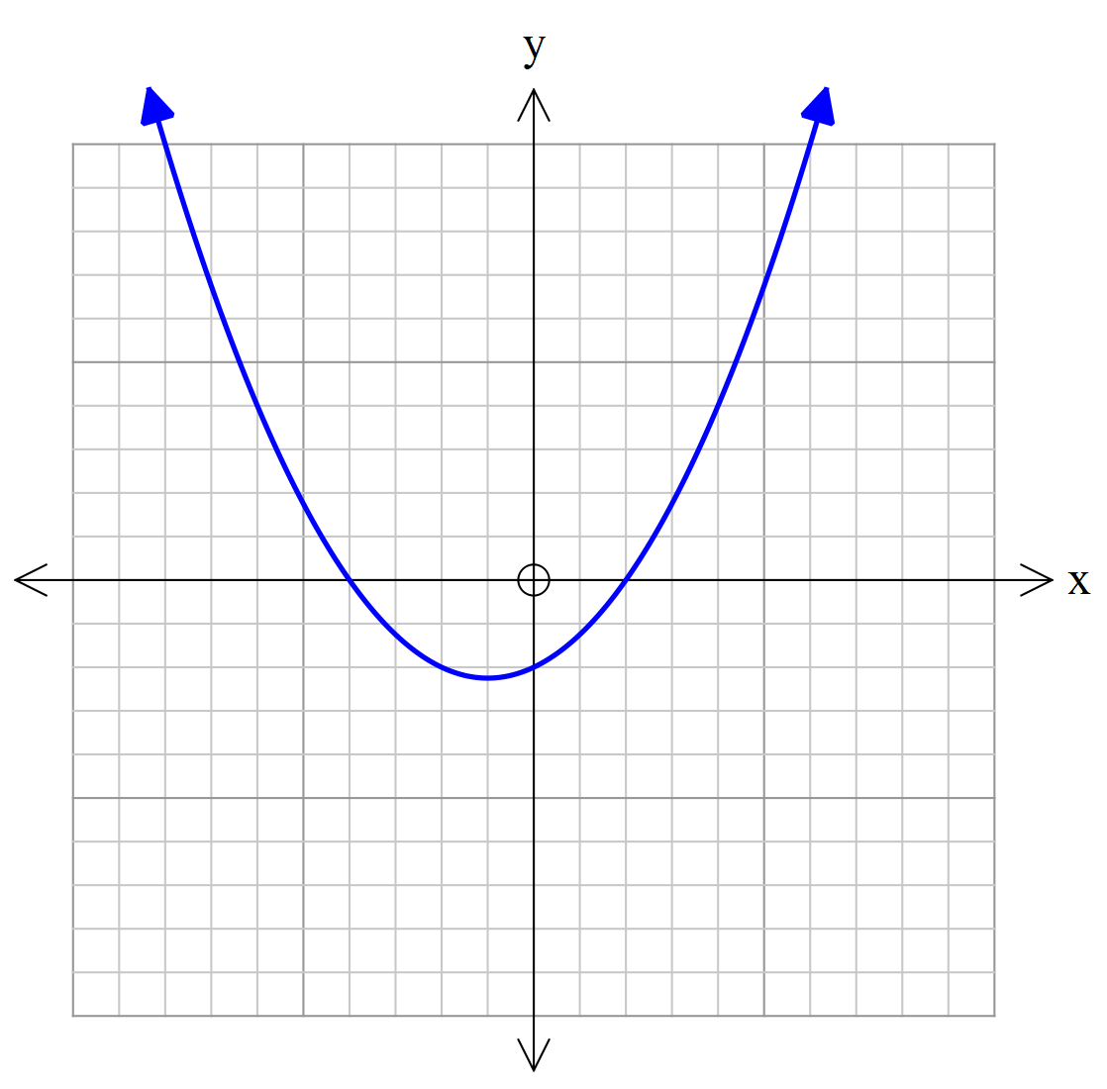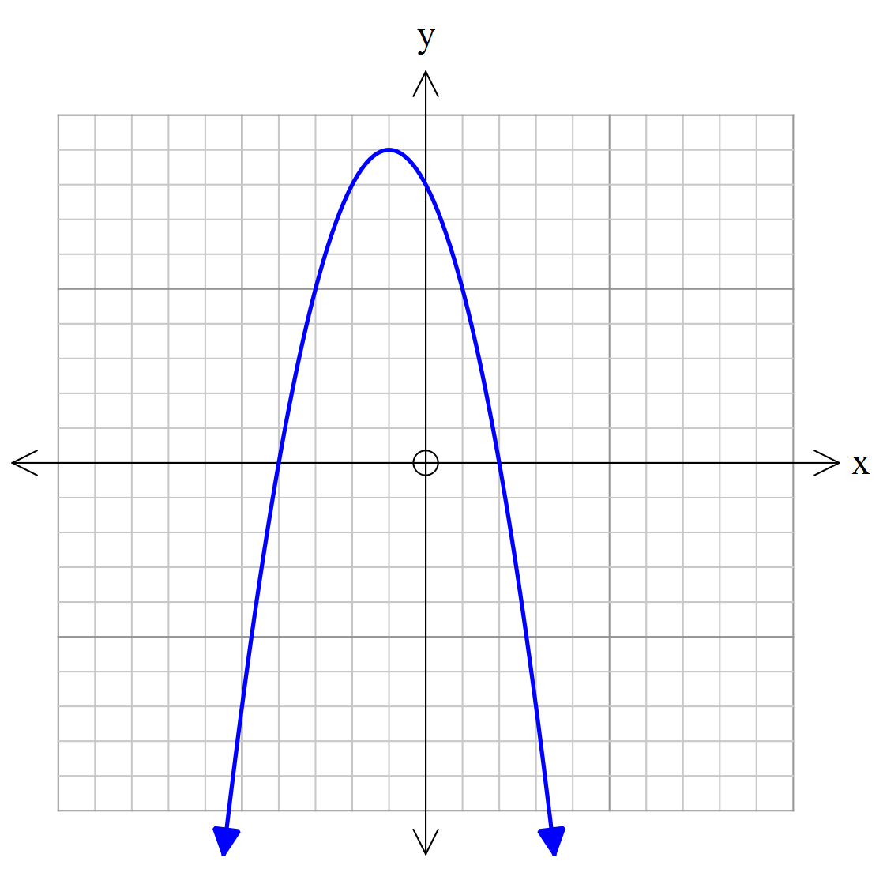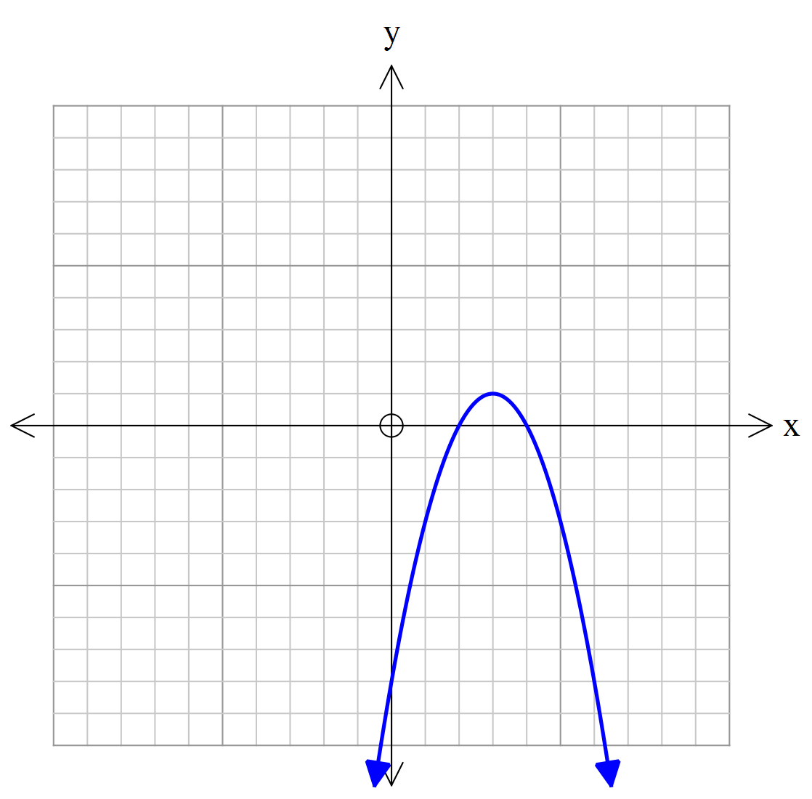

D

E

F

**y = a(x-b)(x+a) Graph _________ y = (x-a)(x-b) Graph ___________**

**y = (x+a)² Graph _________ y = x²-bx – c Graph ___________**

**y = -x²+bx+c Graph _________ y=-(x-a)²+b Graph ___________**

**8. [2, 2, 2 = 6 marks]**

The graph of a reciprocal function has asymptotes with equation x = -2 and y = 4.

a) Write two possible equations for this function.

b) Write the equation of this function if it has a y-intercept at (0, 5).

c) Write the equation of this function if it has a x-intercept at (-3, 0).

**9. [5 marks]**

The sides of a right triangle are (x+1) cm, (x+3) cm and (x+5) cm.

Find the length of each side. TO EARN FULL MARKS YOU MUST SHOWING ALGEBRAIC WORKING.